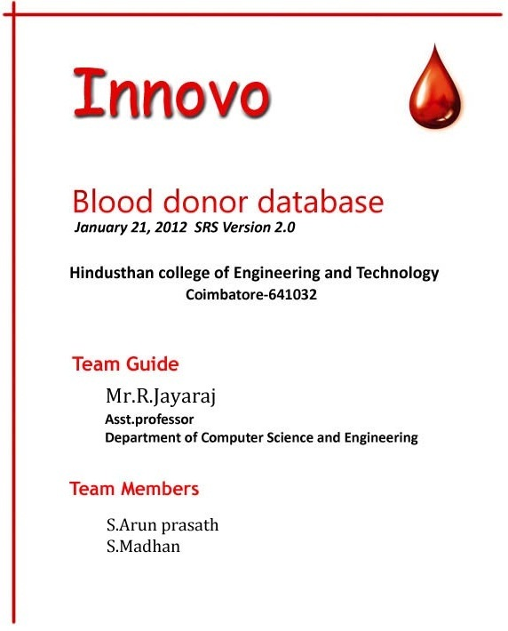

Innovo

Blood donor central database and web-portal

Software Requirements Specification

Version 2.0

Team Guide: Mr.R.Jayaraj

Members: S.Arun prasath
S.Madhan

College Name: Hindusthan College of Engineering and technology

Department: Computer Science and Engineering

State: Tamil Nadu

Revision History

Date | Version | Description | Author
31-12-2011 | 1.0 | Synopsis | Innovo
21-01-2012 | 2.0 | Synopsis – Additional usecase has been added,corresponding activity diagrams are included, additional tables are included. | Innovo

Table of Contents

Description Page no

- Introduction

1.1 Purpose ………………………………………………………..4
1.2 Scope …………………………………………………………..4
1.3 Definition, Acronyms, and Abbreviations ……………….5
1.4 References ……………………………………………………5
1.5 Tools to be used …………………………………………......6
1.6 Overview ………………………………………………………7

- Overall Description

2.1 Product Perspective ………………………………………...7
2.2 Software Interface …………………………………………...8
2.3 Hardware Interface …………………………………………..8
2.4 Use case diagram …………………………………………...10
2.5 Sequence diagram ………………………………………….11
2.6 Activity diagram ……………………………………………..17
2.7 Database design …………………………………………….21
2.8 ER diagram …………………………………………………...22

- Specific requirements

3.1 Use case reports …………………………………………….23

Software Requirements Specification

- Introduction:
Blood donor central database and web-portal is an E-Blood bank which can maintain the records of blood donors and use that in an efficient manner.

  - Purpose:
The Hospitals blood banks and hospitals can look for donors in their nearby area who will be available in quick time . And also keep record of donors health report to evaluate quickly.

  - Scope:

- Administrator have access to all details of blood donors
- The user can register with his basic details like Name, Region, contact details which could be phone number / email and blood group. The details of donors are be saved in such a way that there is less blank spaces like in xml.
- Blood Banks , hospitals etc could browse for blood donors in their nearby area and also the search result is provided for only those donors who have not donated blood in last 3 months
- Blood donors are asked to give feedback of the health report of donors (on basis of their blood taken), for future consideration after the blood donation is being made by donor.
- No user could access any details of donors without being a member of website.
- Only hospitals, blood banks etc should be able to see the contact details of donors (like phone number / email)
- Blood donor could be allowed to see only the name and region they live in. Also if they need to ask another blood donor for any blood donation help it should be through admin and proper reason for which there should be a form to be filled by donor.
- A points should be given to every donor on basis of their blood donation which could be used by blood donors if they need blood for any of their relatives , friends etc. (The priority for making blood available by member blood banks for those donors)

- The search for donors is made flexible , for example a user can give delhi in different forms like , DELHI, delhi, Delhi
- Non-members can also look for blood donors or Bloods in any particular banks and then do quick register through their mobile phones and raise a ticket for Blood requirements
- Maintains the history of blood donation and events.
- FAQ section is included for user benefit.
- Regular health articles are published by Administrator.

  - Definitions, Acronyms, and Abbreviations:

- HTML (Hyper Text Markup Language): It is used to create static web pages.
- JSP (Java Server Pages): It is used to create dynamic web content.
- J2EE (Java 2 Enterprise Edition): It is a programming platform, belonging to the Java platform, which is used for developing and running distributed java applications.
- WASCE (WebSphere Application Server Community Edition): It is an application server that runs and supports the J2EE and the web service applications.
- WSAD (WebSphere Studio Application Developer) : It is a designer toolkit which is designed to develop more complex projects by providing a complete dynamic web service.
- DB2 (IBM Database 2): It is a database management system that provides a flexible and efficient database platform to raise a strong "on demand" business applications.
- HTTP (Hyper Text Transfer Protocol): It is a transaction oriented client/ server protocol between a web browser and a web server.
- BDCDWP(Blood donor central database and web-portal) : It is the web application which maintains the blood donor database for quick access.

  - References
- Object Oriented Modeling and Design with UML-Michael Blaha, James Rambaugh.
- Software Engineering, Seventh Edition, Ian Sommerville.
- IBM Red Books.
- IBM TGMC Sample Synopsis.
- IBM – www.ibm.in/developerworks

  - Tools to be used

Application architecture – JAVA, J2EE

JAVA
Java is an object-oriented programming language developed by Sun Microsystems a company best known for its high end UNIX workstations. Java language was designed to be small, simple, and portable across platforms, operating systems, both at the source and at the binary level, which means that Java programs (applet and application) can run on any machine that has the Java virtual machine (JVM) installed.

J2EE
Java Platform, Enterprise Edition or Java EE is a widely used platform for server programming in the Java programming language. The Java platform (Enterprise Edition) differs from the Java Standard Edition Platform (Java SE) in that it adds libraries which provide functionality to deploy fault-tolerant, distributed, multi-tier Java software, based largely on modular components running on an application server.

Web server – WASCE
WebSphere Application Server Community Edition (from now on WASCE) is a free, certified Java EE 5 server for building and managing Java applications. It is IBM's supported distribution of Apache Geronimo that uses Tomcat for servlet container and Axis 2 for web services. Over 15 WASCE developers are committers in the Apache Geronimo project.

Development tool –RAD
IBM Rational Application Developer for WebSphere Software (RAD) is an integrated development environment (IDE), made by IBM's Rational Software division, for visually designing, constructing, testing, and deploying Web services, portals, and Java (J2EE) applications.

Database platform – DB2
DB2 Database is the database management system that delivers a flexible and cost effective database platform to build robust on demand business applications and supports the J2EE and web services standards.

Design tool – Rational Software Modeler
IBM Rational Software Modeler, (RSM) made by IBM's Rational Software division, is a Unified Modeling Language UML 2.0-based visual modeling and design tool. Rational Software Modeler is built on the Eclipse open-source software framework and includes capabilities focused on visual modeling and model-driven development (MDD) with the UML for creating resilient, thought-out applications and web services.
  - Overview:
The SRS will include two sections, namely:
-I- Overall Description: This section will describe major components of the system, interconnections, and external interfaces.
-I- Specific Requirements: This section will describe the
functions of actors, their roles in the system and the constraints faced by the system.

2.0 Overall Description:

2.1 Product perspectives:

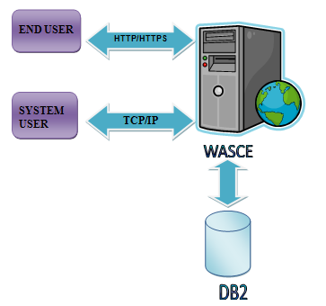

2.2 Software Interface
Client on Internet
Web Browser, Operating System (any)
Client on Intranet
Web Browser, Operating System (any)
Web Server
WASCE, Operating System (any)
Data Base Server
DB2, Operating System (any)
Development End
RAD (J2EE, Java, Java Bean, Servlets, HTML, XML, AJAX), DB2, OS (Windows), WebSphere(Web Server)

2.3 Hardware Interface

Minimum Requirements:
Client Side
 | Processor | RAM | Disk Space
Internet Explorer - 6 | Intel Pentium III or AMD - 800 MHz | 128 MB | 100 MB
Server Side
 | Processor | RAM | Disk Space
RAD | Intel Pentium III or AMD - 800 MHz | 1 GB | 3.5 GB
DB2 - 9.5 | Intel Pentium III or AMD - 800 MHz | 256 MB | 500 MB  (Excluding Data Size)

Recommended Requirements:
Client Side
 | Processor | RAM | Disk Space
Internet Explorer - 6 | All Intel or AMD - 1 GHZ | 256 MB | 100 MB
Server Side
 | Processor | RAM | Disk Space
RAD | All Intel or AMD - 2 GHZ | 2 GB | 3.5 GB
DB2 - 9.5 | All Intel or AMD - 2 GHZ | 512 MB | 500 MB  (Excluding Data Size)

2.4 Use case diagram:

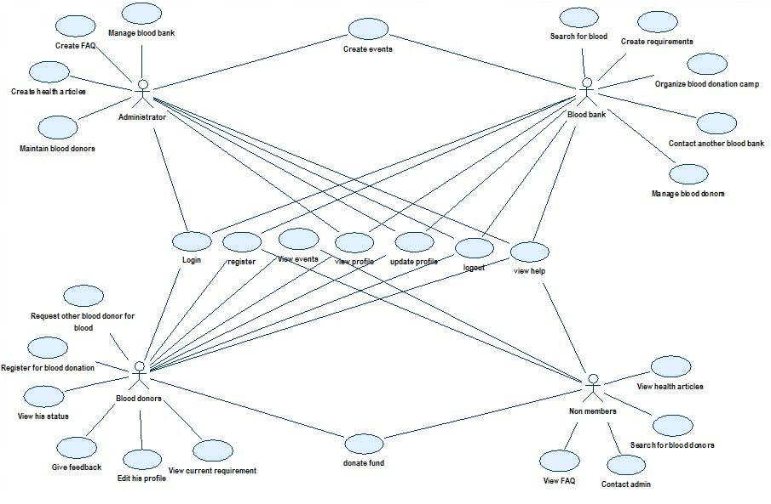

2.5 Sequence diagram:

Blood bank registration:

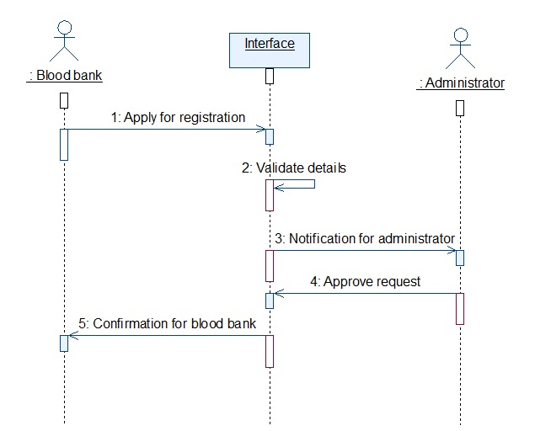

Event creation:

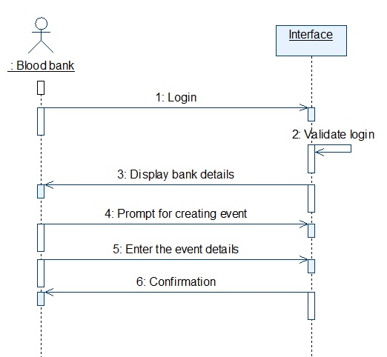

Blood donor login :

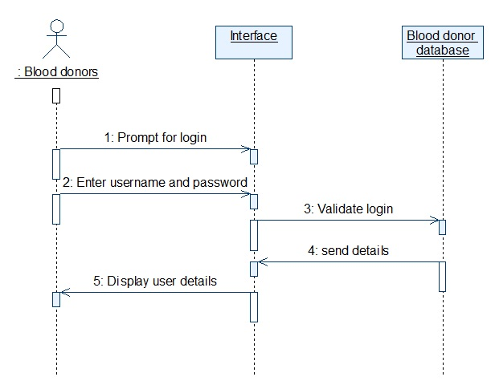

Non member registration:

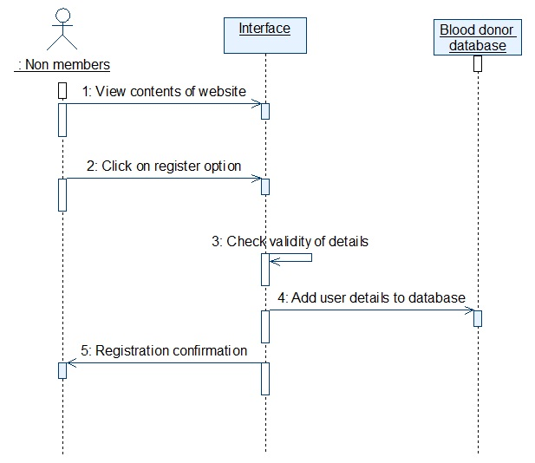

Request another blood donor:

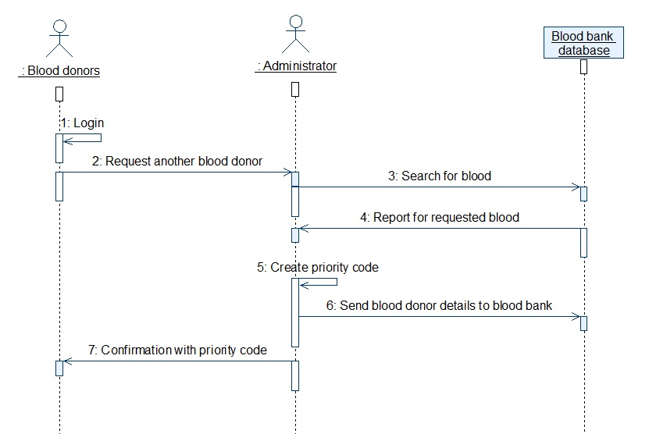

Donation:

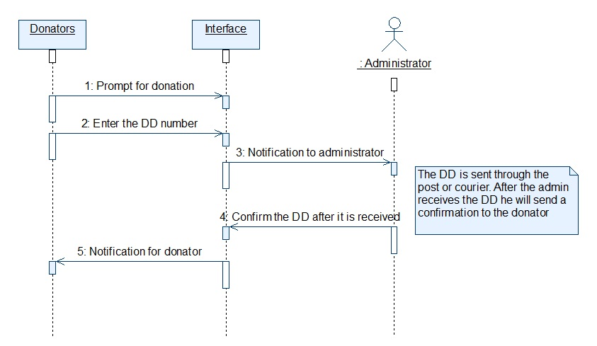

2.6 Activity diagram:

Blood bank approval:

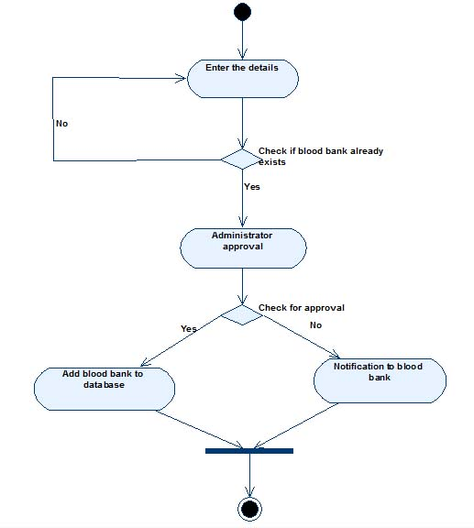

Blood donor registration:

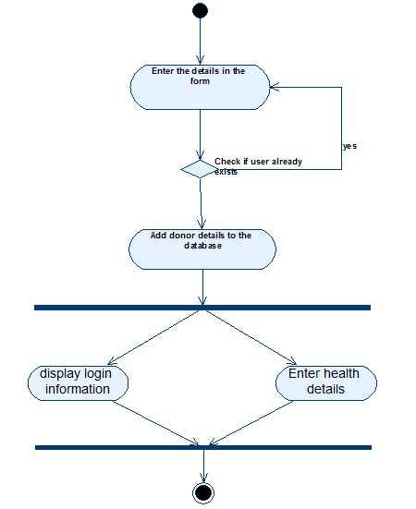

Donate fund:

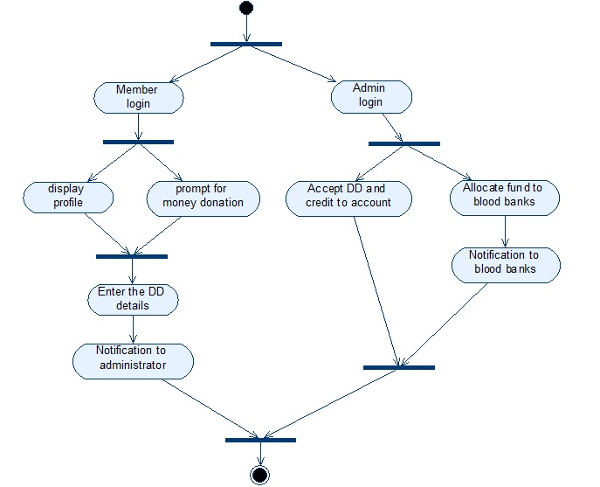

Blood transfer:

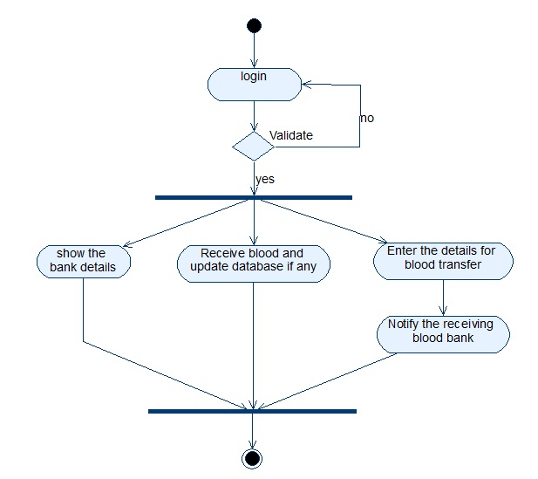

2.7 Database design:

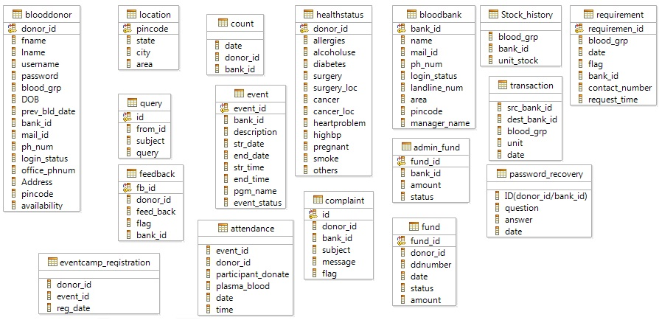

2.8 ER Diagram

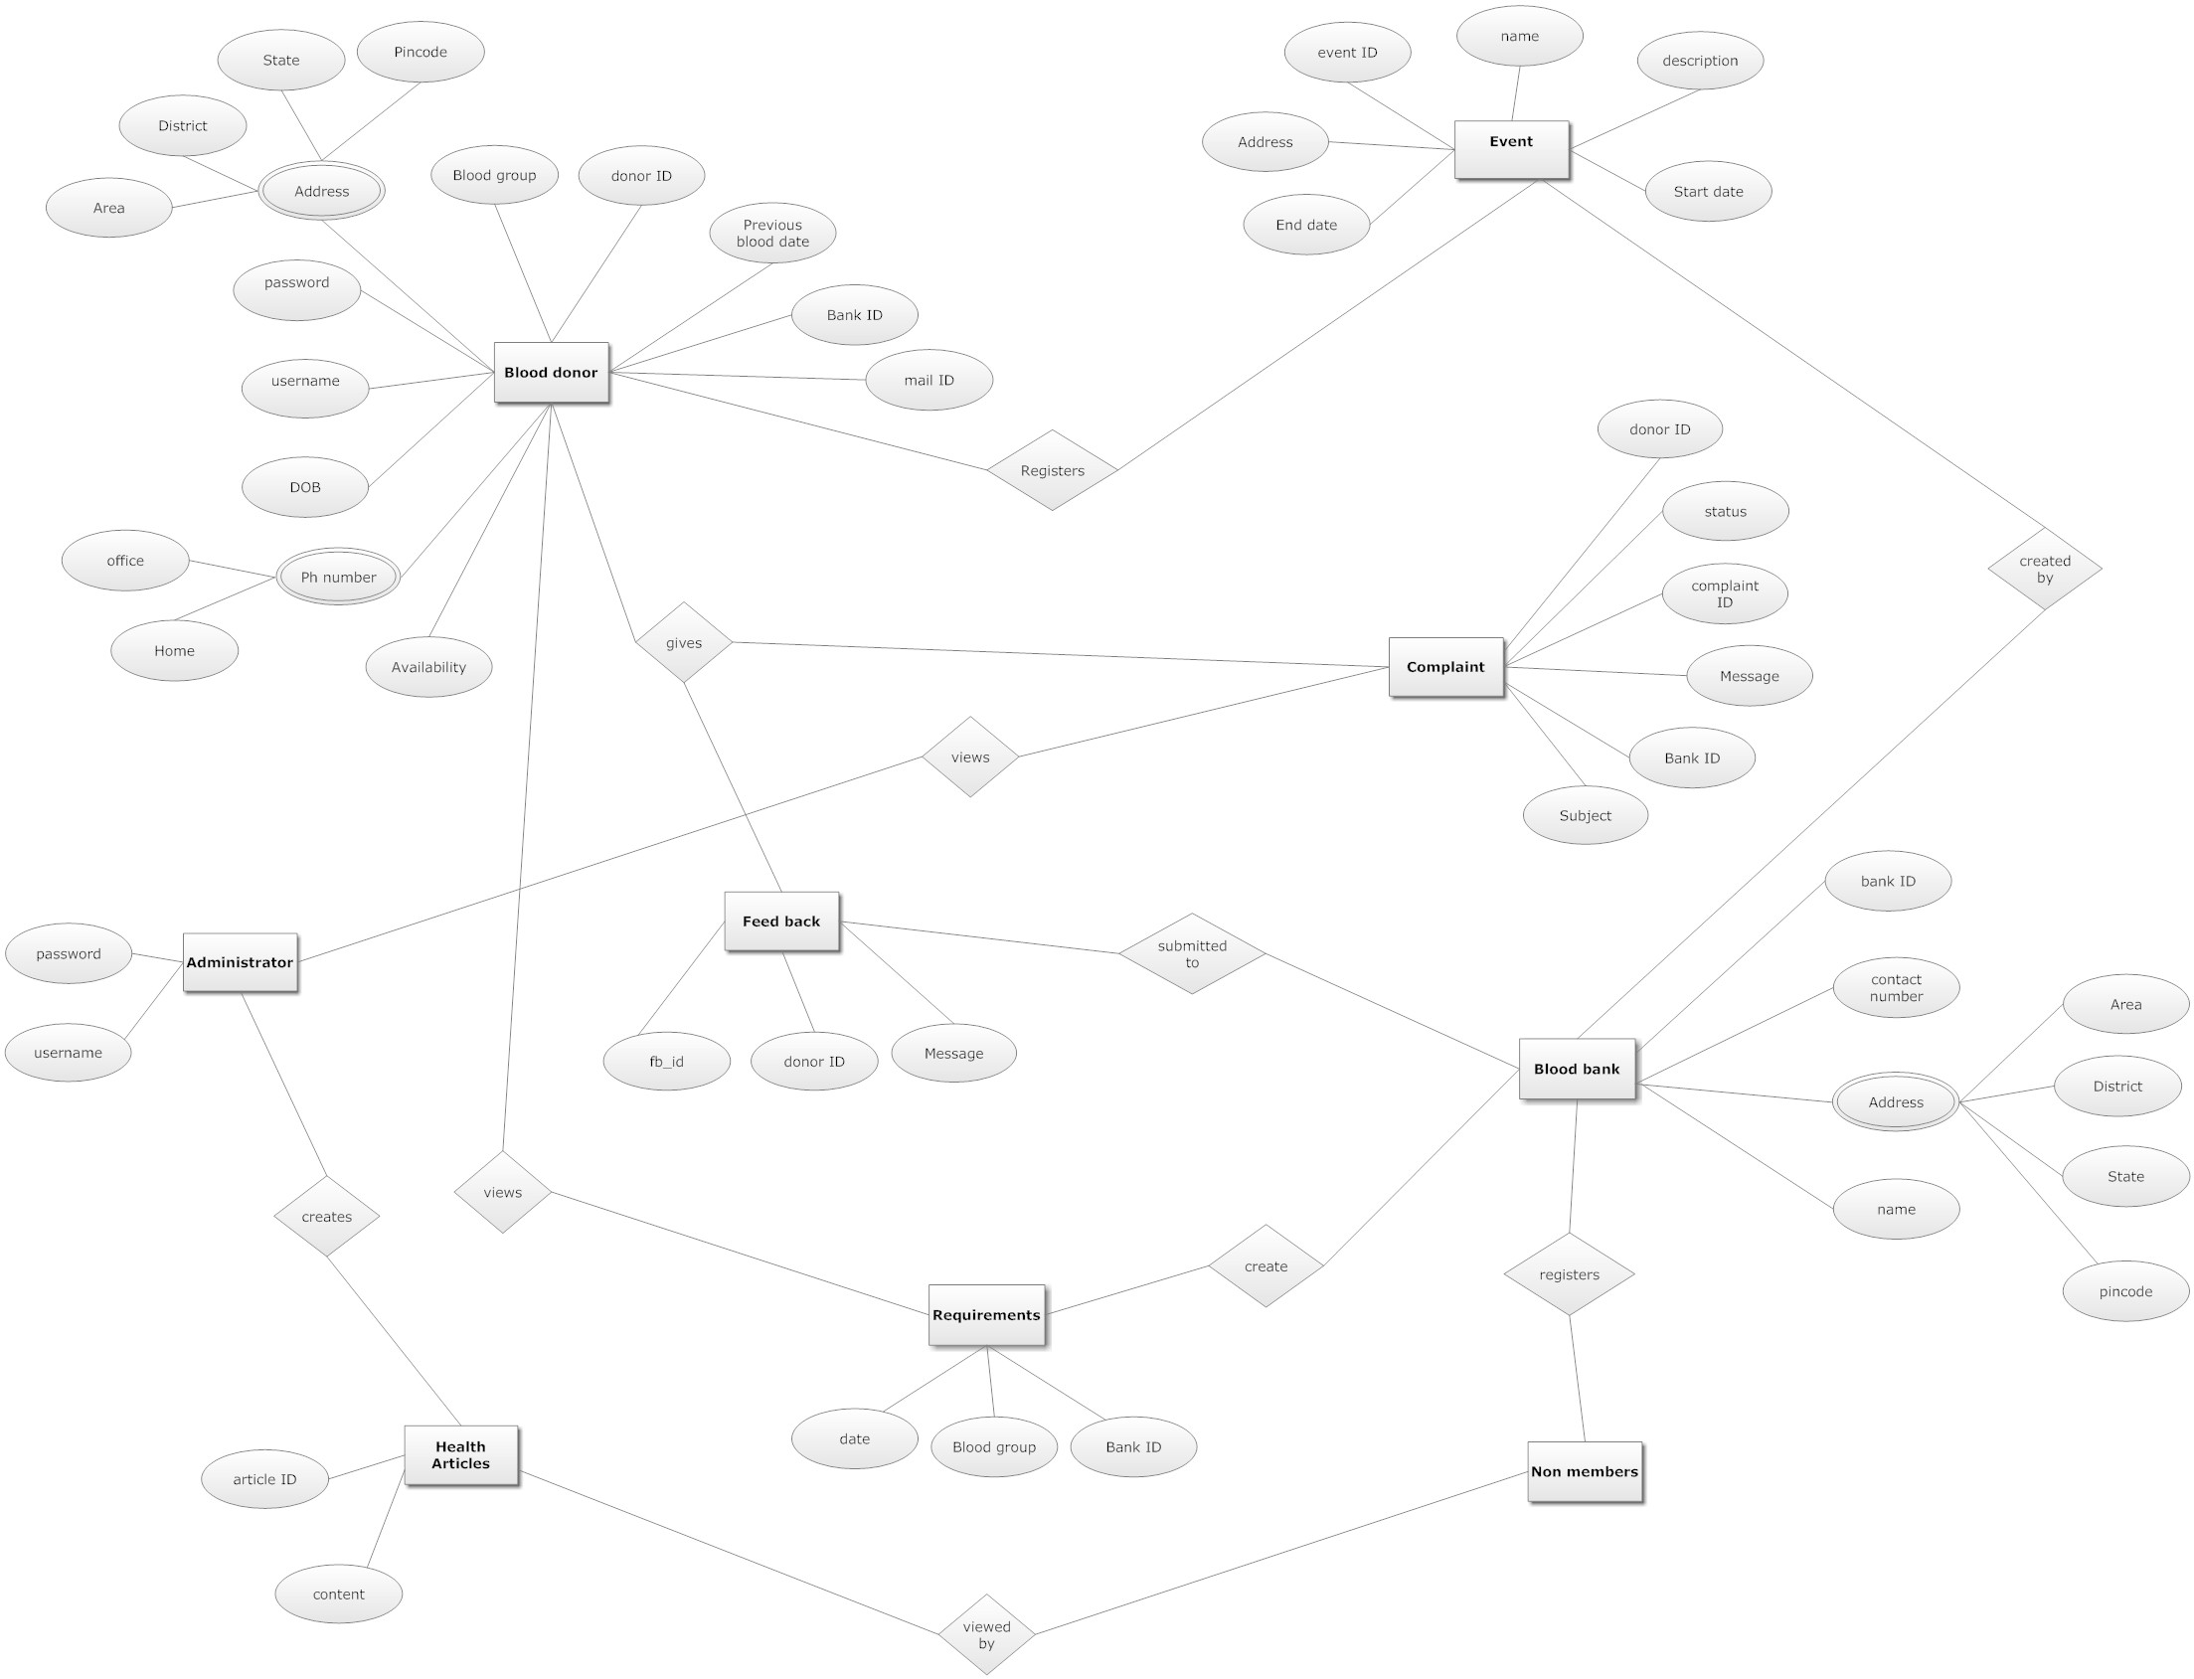

3.0 Specific requirements:

3.1 Use Case Reports:
Non -members:
- Register:
Non members can register in BDCDWP by give mandatory details like username, name , password, email id , phone number and contact details.
- Search for blood donors:
Non members can search for blood donors in the specific address and make a registration to view their details.
- View help:
Non members can view online help and also can download offline help to efficiently use the facilities available in the site.
- View health articles:
Non members can read a health article which was created by administrator.
- View FAQ:
Non members can view the frequently asked questions section and can clear his doubts
- Contact admin:
Non members can query admin by entering his mail address and his query for which admin will reply.

Blood donors:
- Login:
Blood donors can enter into the site by login with his username and password which he provided at the time of registration.
- View his status:
The user can view his details and his history of blood donations.
- Give feedback:
Blood donors can give feedback to administrator about his health records
- Edit profile:
Blood donors can edit their profile and modify his details and also he can delete his account.
- View current requirement:
Blood donors can view the current requirements in his area and can donate blood.
- Register for blood donation:
Blood donors can register for blood donation in blood donation camps which is organized by Blood banks.
- View events:
Blood donors can view an event which is organized by Blood banks and also they can make a quick registration.
- Request other Blood donor:
Blood donor can request other blood donors through administrator and can have more priority than other blood donations

Blood bank:
- Register:
Blood banks can register in the website and can wait for approval from administrator. After approval Blood banks can login.
- Login:
Blood banks can login by using the details which they provided at the time of registration.
- Edit profile:
Blood banks can edit their profile and they also can deactivate their account.
- Create events:
Blood banks can create events with a particular date and can make quick registration for blood donors.
- Organize Blood donation camps:
Blood banks can organize blood donation camps by which members can make registration and can donate blood in the camp.
- Create requirements:
If the Blood banks need any particular blood they can post their requirement on the site by which the Blood donor can view the requirements.
- Search for blood:
Blood banks can access the blood donor database by entering the required blood and the locations if needed.
Administrator:
- Maintain blood bank:
Administrator can add or delete blood bank and also he can update the details of the blood bank.
- Create FAQ:
Administrator can add , remove and update question in ‘Frequently asked Questions’ section which enables the easy understandability of the users.
- Create health articles:
Administrator can create health articles for various topics which may benefit the users.
- Maintain Blood donors:
Administrator can view, add, update and delete the Blood donor details.

**********

